MODIFIED THE FLOW TO CAPTURE THE RESPONSE IN A OUTPUT COMPONENT
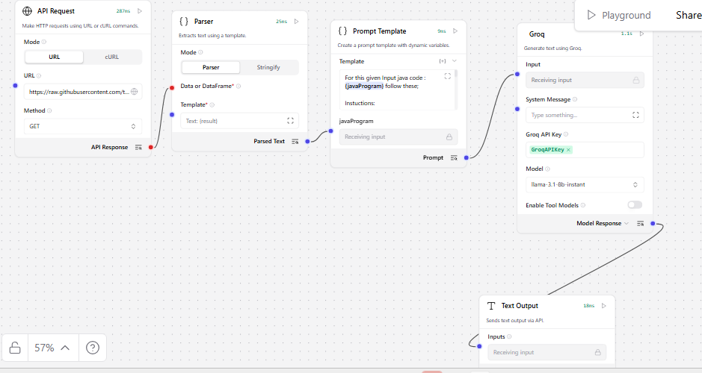
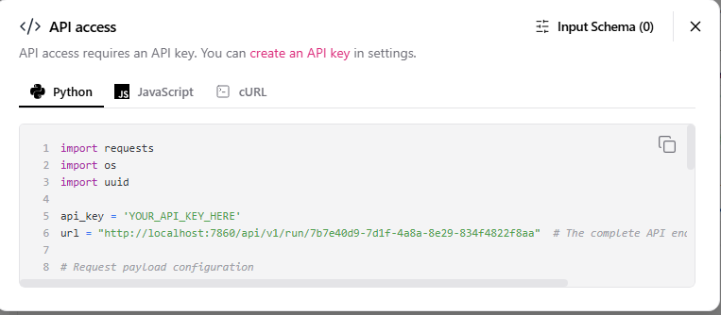
https method is post
input payload is
payload = {
"output_type": "text",
"input_type": "text",
"input_value": "hello world!"
}
url = http://localhost:7860/api/v1/run/7b7e40d9-7d1f-4a8a-8e29-834f4822f8aa
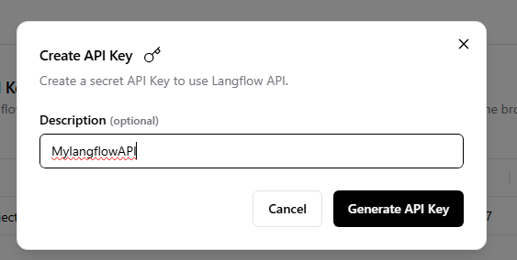
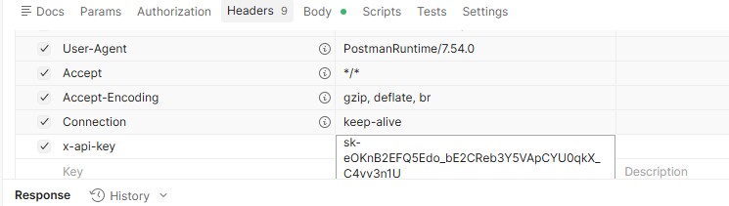
REQUEST PASSED IN POSTMAN
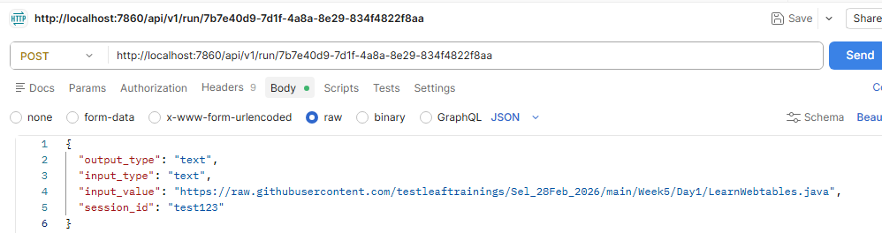
RESPONSE
{
"session_id": "test123",
"outputs": [
{
"inputs": {
"input_value": "https://raw.githubusercontent.com/testleaftrainings/Sel_28Feb_2026/main/Week5/Day1/LearnWebtables.java"
},
"outputs": [
{
"results": {
"text": {
"text_key": "text",
"data": {
"text": "**Code Review Summary**\n\n**Parameter** | **Description** | **Score (out of 20)**\n-------------|---------------|-------------------\n**Code Readability** | Naming conventions are clear, but the code lacks comments or documentation. | 16\n**Code Efficiency** | The code avoids unnecessary loops and redundant logic, but could be optimized for better performance. | 18\n**Error Handling** | The code does not handle exceptions gracefully, and there is no division-by-zero handling. | 10\n**Maintainability** | The class is minimal and not modularized for future extensions. | 14\n**Best Practices & Standards** | The code lacks input validation, unit tests, and proper logging. | 13\n\n**Overall Score:** 71 / 100\n\n**Improvement Areas:**\n\n1. **Add input validation**: Implement checks for potential errors, such as division-by-zero, to ensure robustness.\n2. **Include JavaDoc comments**: Add comments to public methods to provide documentation and clarity.\n3. **Implement basic unit tests**: Write tests to validate the functionality of the code and ensure it meets requirements.\n4. **Improve logging**: Use a logging framework to provide meaningful messages and track errors.\n5. **Modularize the class**: Break down the class into smaller, reusable modules to enhance maintainability.\n\n**Summary:**\nThe code functions correctly but lacks robustness and documentation. Minor improvements can enhance production readiness.\n\n**Detailed Feedback:**\n\n1. **Code Readability**:\n\t* Naming conventions are clear and consistent.\n\t* However, the code lacks comments or documentation, making it difficult for others to understand the purpose and functionality of the code.\n\t* Recommendation: Add JavaDoc comments to public methods and include comments to explain the code's logic.\n2. **Code Efficiency**:\n\t* The code avoids unnecessary loops and redundant logic.\n\t* However, the code could be optimized for better performance, such as using more efficient data structures or algorithms.\n\t* Recommendation: Review the code for potential optimizations and consider using more efficient data structures or algorithms.\n3. **Error Handling**:\n\t* The code does not handle exceptions gracefully, and there is no division-by-zero handling.\n\t* Recommendation: Implement try-catch blocks to handle potential errors and provide meaningful messages.\n4. **Maintainability**:\n\t* The class is minimal and not modularized for future extensions.\n\t* Recommendation: Break down the class into smaller, reusable modules to enhance maintainability.\n5. **Best Practices & Standards**:\n\t* The code lacks input validation, unit tests, and proper logging.\n\t* Recommendation: Implement input validation, write unit tests, and use a logging framework to provide meaningful messages.\n\n**Code Snippets for Improvement:**\n\n1. **Input Validation**:\n```java\npublic void launchBrowser() {\n try {\n // Launch the browser\n ChromeDriver driver = new ChromeDriver();\n // ...\n } catch (Exception e) {\n // Handle exception\n System.out.println(\"Error launching browser: \" + e.getMessage());\n }\n}\n```\n2. **JavaDoc Comments**:\n```java\n/**\n * Launches the browser and loads the specified URL.\n * \n * @param url the URL to load\n */\npublic void launchBrowser(String url) {\n // ...\n}\n```\n3. **Unit Tests**:\n```java\npublic class LearnWebtablesTest {\n @Test\n public void testLaunchBrowser() {\n // Arrange\n String url = \"https://leafground.com/table.xhtml\";\n // Act\n LearnWebtables learnWebtables = new LearnWebtables();\n learnWebtables.launchBrowser(url);\n // Assert\n // Verify that the browser is launched and the URL is loaded\n }\n}\n```\n4. **Logging**:\n```java\nimport org.slf4j.Logger;\nimport org.slf4j.LoggerFactory;\n\npublic class LearnWebtables {\n private static final Logger LOGGER = LoggerFactory.getLogger(LearnWebtables.class);\n\n public void launchBrowser() {\n try {\n // Launch the browser\n ChromeDriver driver = new ChromeDriver();\n // ...\n } catch (Exception e) {\n // Log the exception\n LOGGER.error(\"Error launching browser: \" + e.getMessage());\n }\n }\n}\n```",
"files": [],
"sender": null,
"sender_name": null,
"session_id": "",
"context_id": "",
"timestamp": "2026-05-06 19:03:52 UTC",
"flow_id": "7b7e40d9-7d1f-4a8a-8e29-834f4822f8aa",
"error": false,
"edit": false,
"properties": {
"text_color": null,
"background_color": null,
"edited": false,
"source": {
"id": null,
"display_name": null,
"source": null
},
"icon": null,
"allow_markdown": false,
"positive_feedback": null,
"state": "complete",
"targets": [],
"usage": null,
"build_duration": null
},
"category": "message",
"content_blocks": [],
"duration": null
},
"default_value": "",
"text": "**Code Review Summary**\n\n**Parameter** | **Description** | **Score (out of 20)**\n-------------|---------------|-------------------\n**Code Readability** | Naming conventions are clear, but the code lacks comments or documentation. | 16\n**Code Efficiency** | The code avoids unnecessary loops and redundant logic, but could be optimized for better performance. | 18\n**Error Handling** | The code does not handle exceptions gracefully, and there is no division-by-zero handling. | 10\n**Maintainability** | The class is minimal and not modularized for future extensions. | 14\n**Best Practices & Standards** | The code lacks input validation, unit tests, and proper logging. | 13\n\n**Overall Score:** 71 / 100\n\n**Improvement Areas:**\n\n1. **Add input validation**: Implement checks for potential errors, such as division-by-zero, to ensure robustness.\n2. **Include JavaDoc comments**: Add comments to public methods to provide documentation and clarity.\n3. **Implement basic unit tests**: Write tests to validate the functionality of the code and ensure it meets requirements.\n4. **Improve logging**: Use a logging framework to provide meaningful messages and track errors.\n5. **Modularize the class**: Break down the class into smaller, reusable modules to enhance maintainability.\n\n**Summary:**\nThe code functions correctly but lacks robustness and documentation. Minor improvements can enhance production readiness.\n\n**Detailed Feedback:**\n\n1. **Code Readability**:\n\t* Naming conventions are clear and consistent.\n\t* However, the code lacks comments or documentation, making it difficult for others to understand the purpose and functionality of the code.\n\t* Recommendation: Add JavaDoc comments to public methods and include comments to explain the code's logic.\n2. **Code Efficiency**:\n\t* The code avoids unnecessary loops and redundant logic.\n\t* However, the code could be optimized for better performance, such as using more efficient data structures or algorithms.\n\t* Recommendation: Review the code for potential optimizations and consider using more efficient data structures or algorithms.\n3. **Error Handling**:\n\t* The code does not handle exceptions gracefully, and there is no division-by-zero handling.\n\t* Recommendation: Implement try-catch blocks to handle potential errors and provide meaningful messages.\n4. **Maintainability**:\n\t* The class is minimal and not modularized for future extensions.\n\t* Recommendation: Break down the class into smaller, reusable modules to enhance maintainability.\n5. **Best Practices & Standards**:\n\t* The code lacks input validation, unit tests, and proper logging.\n\t* Recommendation: Implement input validation, write unit tests, and use a logging framework to provide meaningful messages.\n\n**Code Snippets for Improvement:**\n\n1. **Input Validation**:\n```java\npublic void launchBrowser() {\n try {\n // Launch the browser\n ChromeDriver driver = new ChromeDriver();\n // ...\n } catch (Exception e) {\n // Handle exception\n System.out.println(\"Error launching browser: \" + e.getMessage());\n }\n}\n```\n2. **JavaDoc Comments**:\n```java\n/**\n * Launches the browser and loads the specified URL.\n * \n * @param url the URL to load\n */\npublic void launchBrowser(String url) {\n // ...\n}\n```\n3. **Unit Tests**:\n```java\npublic class LearnWebtablesTest {\n @Test\n public void testLaunchBrowser() {\n // Arrange\n String url = \"https://leafground.com/table.xhtml\";\n // Act\n LearnWebtables learnWebtables = new LearnWebtables();\n learnWebtables.launchBrowser(url);\n // Assert\n // Verify that the browser is launched and the URL is loaded\n }\n}\n```\n4. **Logging**:\n```java\nimport org.slf4j.Logger;\nimport org.slf4j.LoggerFactory;\n\npublic class LearnWebtables {\n private static final Logger LOGGER = LoggerFactory.getLogger(LearnWebtables.class);\n\n public void launchBrowser() {\n try {\n // Launch the browser\n ChromeDriver driver = new ChromeDriver();\n // ...\n } catch (Exception e) {\n // Log the exception\n LOGGER.error(\"Error launching browser: \" + e.getMessage());\n }\n }\n}\n```",
"sender": null,
"sender_name": null,
"files": [],
"session_id": "",
"context_id": "",
"timestamp": "2026-05-06T19:03:52+00:00",
"flow_id": "7b7e40d9-7d1f-4a8a-8e29-834f4822f8aa",
"error": false,
"edit": false,
"properties": {
"text_color": null,
"background_color": null,
"edited": false,
"source": {
"id": null,
"display_name": null,
"source": null
},
"icon": null,
"allow_markdown": false,
"positive_feedback": null,
"state": "complete",
"targets": [],
"usage": null,
"build_duration": null
},
"category": "message",
"content_blocks": [],
"duration": null
}
},
"artifacts": {
"text": {
"repr": "**Code Review Summary**\n\n**Parameter** | **Description** | **Score (out of 20)**\n-------------|---------------|-------------------\n**Code Readability** | Naming conventions are clear, but the code lacks comments or documentation. | 16\n**Code Efficiency** | The code avoids unnecessary loops and redundant logic, but could be optimized for better performance. | 18\n**Error Handling** | The code does not handle exceptions gracefully, and there is no division-by-zero handling. | 10\n**Maintainability** | The class is minimal and not modularized for future extensions. | 14\n**Best Practices & Standards** | The code lacks input validation, unit tests, and proper logging. | 13\n\n**Overall Score:** 71 / 100\n\n**Improvement Areas:**\n\n1. **Add input validation**: Implement checks for potential errors, such as division-by-zero, to ensure robustness.\n2. **Include JavaDoc comments**: Add comments to public methods to provide documentation and clarity.\n3. **Implement basic unit tests**: Write tests to validate the functionality of the code and ensure it meets requirements.\n4. **Improve logging**: Use a logging framework to provide meaningful messages and track errors.\n5. **Modularize the class**: Break down the class into smaller, reusable modules to enhance maintainability.\n\n**Summary:**\nThe code functions correctly but lacks robustness and documentation. Minor improvements can enhance production readiness.\n\n**Detailed Feedback:**\n\n1. **Code Readability**:\n\t* Naming conventions are clear and consistent.\n\t* However, the code lacks comments or documentation, making it difficult for others to understand the purpose and functionality of the code.\n\t* Recommendation: Add JavaDoc comments to public methods and include comments to explain the code's logic.\n2. **Code Efficiency**:\n\t* The code avoids unnecessary loops and redundant logic.\n\t* However, the code could be optimized for better performance, such as using more efficient data structures or algorithms.\n\t* Recommendation: Review the code for potential optimizations and consider using more efficient data structures or algorithms.\n3. **Error Handling**:\n\t* The code does not handle exceptions gracefully, and there is no division-by-zero handling.\n\t* Recommendation: Implement try-catch blocks to handle potential errors and provide meaningful messages.\n4. **Maintainability**:\n\t* The class is minimal and not modularized for future extensions.\n\t* Recommendation: Break down the class into smaller, reusable modules to enhance maintainability.\n5. **Best Practices & Standards**:\n\t* The code lacks input validation, unit tests, and proper logging.\n\t* Recommendation: Implement input validation, write unit tests, and use a logging framework to provide meaningful messages.\n\n**Code Snippets for Improvement:**\n\n1. **Input Validation**:\n```java\npublic void launchBrowser() {\n try {\n // Launch the browser\n ChromeDriver driver = new ChromeDriver();\n // ...\n } catch (Exception e) {\n // Handle exception\n System.out.println(\"Error launching browser: \" + e.getMessage());\n }\n}\n```\n2. **JavaDoc Comments**:\n```java\n/**\n * Launches the browser and loads the specified URL.\n * \n * @param url the URL to load\n */\npublic void launchBrowser(String url) {\n // ...\n}\n```\n3. **Unit Tests**:\n```java\npublic class LearnWebtablesTest {\n @Test\n public void testLaunchBrowser() {\n // Arrange\n String url = \"https://leafground.com/table.xhtml\";\n // Act\n LearnWebtables learnWebtables = new LearnWebtables();\n learnWebtables.launchBrowser(url);\n // Assert\n // Verify that the browser is launched and the URL is loaded\n }\n}\n```\n4. **Logging**:\n```java\nimport org.slf4j.Logger;\nimport org.slf4j.LoggerFactory;\n\npublic class LearnWebtables {\n private static final Logger LOGGER = LoggerFactory.getLogger(LearnWebtables.class);\n\n public void launchBrowser() {\n try {\n // Launch the browser\n ChromeDriver driver = new ChromeDriver();\n // ...\n } catch (Exception e) {\n // Log the exception\n LOGGER.error(\"Error launching browser: \" + e.getMessage());\n }\n }\n}\n```",
"raw": "**Code Review Summary**\n\n**Parameter** | **Description** | **Score (out of 20)**\n-------------|---------------|-------------------\n**Code Readability** | Naming conventions are clear, but the code lacks comments or documentation. | 16\n**Code Efficiency** | The code avoids unnecessary loops and redundant logic, but could be optimized for better performance. | 18\n**Error Handling** | The code does not handle exceptions gracefully, and there is no division-by-zero handling. | 10\n**Maintainability** | The class is minimal and not modularized for future extensions. | 14\n**Best Practices & Standards** | The code lacks input validation, unit tests, and proper logging. | 13\n\n**Overall Score:** 71 / 100\n\n**Improvement Areas:**\n\n1. **Add input validation**: Implement checks for potential errors, such as division-by-zero, to ensure robustness.\n2. **Include JavaDoc comments**: Add comments to public methods to provide documentation and clarity.\n3. **Implement basic unit tests**: Write tests to validate the functionality of the code and ensure it meets requirements.\n4. **Improve logging**: Use a logging framework to provide meaningful messages and track errors.\n5. **Modularize the class**: Break down the class into smaller, reusable modules to enhance maintainability.\n\n**Summary:**\nThe code functions correctly but lacks robustness and documentation. Minor improvements can enhance production readiness.\n\n**Detailed Feedback:**\n\n1. **Code Readability**:\n\t* Naming conventions are clear and consistent.\n\t* However, the code lacks comments or documentation, making it difficult for others to understand the purpose and functionality of the code.\n\t* Recommendation: Add JavaDoc comments to public methods and include comments to explain the code's logic.\n2. **Code Efficiency**:\n\t* The code avoids unnecessary loops and redundant logic.\n\t* However, the code could be optimized for better performance, such as using more efficient data structures or algorithms.\n\t* Recommendation: Review the code for potential optimizations and consider using more efficient data structures or algorithms.\n3. **Error Handling**:\n\t* The code does not handle exceptions gracefully, and there is no division-by-zero handling.\n\t* Recommendation: Implement try-catch blocks to handle potential errors and provide meaningful messages.\n4. **Maintainability**:\n\t* The class is minimal and not modularized for future extensions.\n\t* Recommendation: Break down the class into smaller, reusable modules to enhance maintainability.\n5. **Best Practices & Standards**:\n\t* The code lacks input validation, unit tests, and proper logging.\n\t* Recommendation: Implement input validation, write unit tests, and use a logging framework to provide meaningful messages.\n\n**Code Snippets for Improvement:**\n\n1. **Input Validation**:\n```java\npublic void launchBrowser() {\n try {\n // Launch the browser\n ChromeDriver driver = new ChromeDriver();\n // ...\n } catch (Exception e) {\n // Handle exception\n System.out.println(\"Error launching browser: \" + e.getMessage());\n }\n}\n```\n2. **JavaDoc Comments**:\n```java\n/**\n * Launches the browser and loads the specified URL.\n * \n * @param url the URL to load\n */\npublic void launchBrowser(String url) {\n // ...\n}\n```\n3. **Unit Tests**:\n```java\npublic class LearnWebtablesTest {\n @Test\n public void testLaunchBrowser() {\n // Arrange\n String url = \"https://leafground.com/table.xhtml\";\n // Act\n LearnWebtables learnWebtables = new LearnWebtables();\n learnWebtables.launchBrowser(url);\n // Assert\n // Verify that the browser is launched and the URL is loaded\n }\n}\n```\n4. **Logging**:\n```java\nimport org.slf4j.Logger;\nimport org.slf4j.LoggerFactory;\n\npublic class LearnWebtables {\n private static final Logger LOGGER = LoggerFactory.getLogger(LearnWebtables.class);\n\n public void launchBrowser() {\n try {\n // Launch the browser\n ChromeDriver driver = new ChromeDriver();\n // ...\n } catch (Exception e) {\n // Log the exception\n LOGGER.error(\"Error launching browser: \" + e.getMessage());\n }\n }\n}\n```",
"type": "text"
}
},
"outputs": {
"text": {
"message": "**Code Review Summary**\n\n**Parameter** | **Description** | **Score (out of 20)**\n-------------|---------------|-------------------\n**Code Readability** | Naming conventions are clear, but the code lacks comments or documentation. | 16\n**Code Efficiency** | The code avoids unnecessary loops and redundant logic, but could be optimized for better performance. | 18\n**Error Handling** | The code does not handle exceptions gracefully, and there is no division-by-zero handling. | 10\n**Maintainability** | The class is minimal and not modularized for future extensions. | 14\n**Best Practices & Standards** | The code lacks input validation, unit tests, and proper logging. | 13\n\n**Overall Score:** 71 / 100\n\n**Improvement Areas:**\n\n1. **Add input validation**: Implement checks for potential errors, such as division-by-zero, to ensure robustness.\n2. **Include JavaDoc comments**: Add comments to public methods to provide documentation and clarity.\n3. **Implement basic unit tests**: Write tests to validate the functionality of the code and ensure it meets requirements.\n4. **Improve logging**: Use a logging framework to provide meaningful messages and track errors.\n5. **Modularize the class**: Break down the class into smaller, reusable modules to enhance maintainability.\n\n**Summary:**\nThe code functions correctly but lacks robustness and documentation. Minor improvements can enhance production readiness.\n\n**Detailed Feedback:**\n\n1. **Code Readability**:\n\t* Naming conventions are clear and consistent.\n\t* However, the code lacks comments or documentation, making it difficult for others to understand the purpose and functionality of the code.\n\t* Recommendation: Add JavaDoc comments to public methods and include comments to explain the code's logic.\n2. **Code Efficiency**:\n\t* The code avoids unnecessary loops and redundant logic.\n\t* However, the code could be optimized for better performance, such as using more efficient data structures or algorithms.\n\t* Recommendation: Review the code for potential optimizations and consider using more efficient data structures or algorithms.\n3. **Error Handling**:\n\t* The code does not handle exceptions gracefully, and there is no division-by-zero handling.\n\t* Recommendation: Implement try-catch blocks to handle potential errors and provide meaningful messages.\n4. **Maintainability**:\n\t* The class is minimal and not modularized for future extensions.\n\t* Recommendation: Break down the class into smaller, reusable modules to enhance maintainability.\n5. **Best Practices & Standards**:\n\t* The code lacks input validation, unit tests, and proper logging.\n\t* Recommendation: Implement input validation, write unit tests, and use a logging framework to provide meaningful messages.\n\n**Code Snippets for Improvement:**\n\n1. **Input Validation**:\n```java\npublic void launchBrowser() {\n try {\n // Launch the browser\n ChromeDriver driver = new ChromeDriver();\n // ...\n } catch (Exception e) {\n // Handle exception\n System.out.println(\"Error launching browser: \" + e.getMessage());\n }\n}\n```\n2. **JavaDoc Comments**:\n```java\n/**\n * Launches the browser and loads the specified URL.\n * \n * @param url the URL to load\n */\npublic void launchBrowser(String url) {\n // ...\n}\n```\n3. **Unit Tests**:\n```java\npublic class LearnWebtablesTest {\n @Test\n public void testLaunchBrowser() {\n // Arrange\n String url = \"https://leafground.com/table.xhtml\";\n // Act\n LearnWebtables learnWebtables = new LearnWebtables();\n learnWebtables.launchBrowser(url);\n // Assert\n // Verify that the browser is launched and the URL is loaded\n }\n}\n```\n4. **Logging**:\n```java\nimport org.slf4j.Logger;\nimport org.slf4j.LoggerFactory;\n\npublic class LearnWebtables {\n private static final Logger LOGGER = LoggerFactory.getLogger(LearnWebtables.class);\n\n public void launchBrowser() {\n try {\n // Launch the browser\n ChromeDriver driver = new ChromeDriver();\n // ...\n } catch (Exception e) {\n // Log the exception\n LOGGER.error(\"Error launching browser: \" + e.getMessage());\n }\n }\n}\n```",
"type": "text"
}
},
"logs": {
"text": []
},
"messages": [
{
"message": "**Code Review Summary**\n\n**Parameter** | **Description** | **Score (out of 20)**\n\n-------------|---------------|-------------------\n\n**Code Readability** | Naming conventions are clear, but the code lacks comments or documentation. | 16\n\n**Code Efficiency** | The code avoids unnecessary loops and redundant logic, but could be optimized for better performance. | 18\n\n**Error Handling** | The code does not handle exceptions gracefully, and there is no division-by-zero handling. | 10\n\n**Maintainability** | The class is minimal and not modularized for future extensions. | 14\n\n**Best Practices & Standards** | The code lacks input validation, unit tests, and proper logging. | 13\n\n**Overall Score:** 71 / 100\n\n**Improvement Areas:**\n\n1. **Add input validation**: Implement checks for potential errors, such as division-by-zero, to ensure robustness.\n\n2. **Include JavaDoc comments**: Add comments to public methods to provide documentation and clarity.\n\n3. **Implement basic unit tests**: Write tests to validate the functionality of the code and ensure it meets requirements.\n\n4. **Improve logging**: Use a logging framework to provide meaningful messages and track errors.\n\n5. **Modularize the class**: Break down the class into smaller, reusable modules to enhance maintainability.\n\n**Summary:**\n\nThe code functions correctly but lacks robustness and documentation. Minor improvements can enhance production readiness.\n\n**Detailed Feedback:**\n\n1. **Code Readability**:\n\n\t* Naming conventions are clear and consistent.\n\n\t* However, the code lacks comments or documentation, making it difficult for others to understand the purpose and functionality of the code.\n\n\t* Recommendation: Add JavaDoc comments to public methods and include comments to explain the code's logic.\n\n2. **Code Efficiency**:\n\n\t* The code avoids unnecessary loops and redundant logic.\n\n\t* However, the code could be optimized for better performance, such as using more efficient data structures or algorithms.\n\n\t* Recommendation: Review the code for potential optimizations and consider using more efficient data structures or algorithms.\n\n3. **Error Handling**:\n\n\t* The code does not handle exceptions gracefully, and there is no division-by-zero handling.\n\n\t* Recommendation: Implement try-catch blocks to handle potential errors and provide meaningful messages.\n\n4. **Maintainability**:\n\n\t* The class is minimal and not modularized for future extensions.\n\n\t* Recommendation: Break down the class into smaller, reusable modules to enhance maintainability.\n\n5. **Best Practices & Standards**:\n\n\t* The code lacks input validation, unit tests, and proper logging.\n\n\t* Recommendation: Implement input validation, write unit tests, and use a logging framework to provide meaningful messages.\n\n**Code Snippets for Improvement:**\n\n1. **Input Validation**:\n\n```java\n\npublic void launchBrowser() {\n\n try {\n\n // Launch the browser\n\n ChromeDriver driver = new ChromeDriver();\n\n // ...\n\n } catch (Exception e) {\n\n // Handle exception\n\n System.out.println(\"Error launching browser: \" + e.getMessage());\n\n }\n\n}\n\n```\n\n2. **JavaDoc Comments**:\n\n```java\n\n/**\n\n * Launches the browser and loads the specified URL.\n\n * \n\n * @param url the URL to load\n\n */\n\npublic void launchBrowser(String url) {\n\n // ...\n\n}\n\n```\n\n3. **Unit Tests**:\n\n```java\n\npublic class LearnWebtablesTest {\n\n @Test\n\n public void testLaunchBrowser() {\n\n // Arrange\n\n String url = \"https://leafground.com/table.xhtml\";\n\n // Act\n\n LearnWebtables learnWebtables = new LearnWebtables();\n\n learnWebtables.launchBrowser(url);\n\n // Assert\n\n // Verify that the browser is launched and the URL is loaded\n\n }\n\n}\n\n```\n\n4. **Logging**:\n\n```java\n\nimport org.slf4j.Logger;\n\nimport org.slf4j.LoggerFactory;\n\npublic class LearnWebtables {\n\n private static final Logger LOGGER = LoggerFactory.getLogger(LearnWebtables.class);\n\n public void launchBrowser() {\n\n try {\n\n // Launch the browser\n\n ChromeDriver driver = new ChromeDriver();\n\n // ...\n\n } catch (Exception e) {\n\n // Log the exception\n\n LOGGER.error(\"Error launching browser: \" + e.getMessage());\n\n }\n\n }\n\n}\n\n```",
"sender": "Machine",
"sender_name": "AI",
"session_id": "",
"stream_url": null,
"component_id": "TextOutput-tjpRh",
"files": [],
"type": "text"
}
],
"timedelta": null,
"duration": null,
"component_display_name": "Text Output",
"component_id": "TextOutput-tjpRh",
"used_frozen_result": false
}
]
}
]
}

LETS ADD THE INPUT SCHEMA VALUES
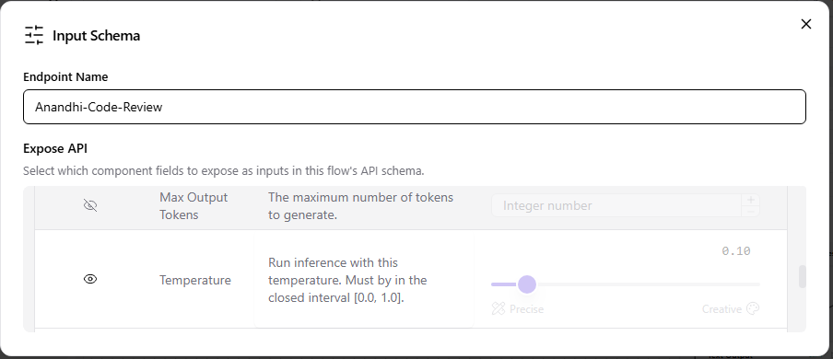
The URL and request payload would be modified as below
url = "http://localhost:7860/api/v1/run/Anandhi-Code-Review" # The complete API endpoint URL for this flow
# Request payload configuration
payload = {
"output_type": "text",
"input_type": "text",
"input_value": "hello world!",
"tweaks": {
"GroqModel-QW9X8": {
"temperature": 0.1
}
}
}

Lets invoke the postman collection with this new payload and URL
